
JUNIOR NOQUE 2015 ENTRY FORM

RACE DAY: FRIDAY, JANUARY 23, 2015
LOWER NOQUE TRAIL- FORESTVILLE TRAILHEAD
RACE ENTERING
FEE SCHEDULE
RACE INFORMATION
 1 km classic race, ages 7 & under
 3 km freestyle race, ages 8-11
 5 km classic race, ages 12-19

Received by: Jan. 17…$8.00
Race Day….$15.00
Registration included for youth enrolled in 2014/15 Superiorland Ski Club programs if registration is received by 1/17/15.
Make checks payable to: Junior Noque
Mail to: PO Box 746
Marquette, MI 49855

Phone: 906.235.6861

Or drop off at NTN office at Lakeview Arena in Marquette
NEW race times, age groups and restructured races.

~5km Classic starts at 3:45 pm and is for skiers ages 18 and under. Age groups: U18 (16-17), U16 (14-15), U14 (12 -13.
~3 km Freestyle starts at 4:30 pm and is for skiers U12 (10-11), U10 (8-9).
~1 km Classic (untimed) starts at 5:00 pm and is for skiers ages 7 and under. All ages as of Dec. 31st.

All races are at the Forestville Trailhead of Lower Noque Trail on looped courses.
Awards ceremony takes place immediately after races are finished and results are tallied. Heated building will be available along with food and refreshments. Overall and age group awards will be presented (1k is overall only). All racers will receive a blue ribbon with their bibs. Parents are allowed to ski with children at back of race.
.

PERSONAL INFO
**Very Important!**
 Male  Female
Age at race date: ______
Date of birth: __________

SKIER INFO

Entrant’s Name Parent/guardian’s name

Address

City, State, Zip

Phone

Club or Team
PAYMENT

Only payments by cash or checks please
$
Check number:
Entry void if not accompanied by correct entry fee in US funds. Non-transferable and non-refundable. Racers’ parent or legal guardian must sign a release and indemnity agreement at registration.
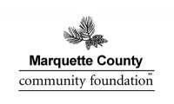
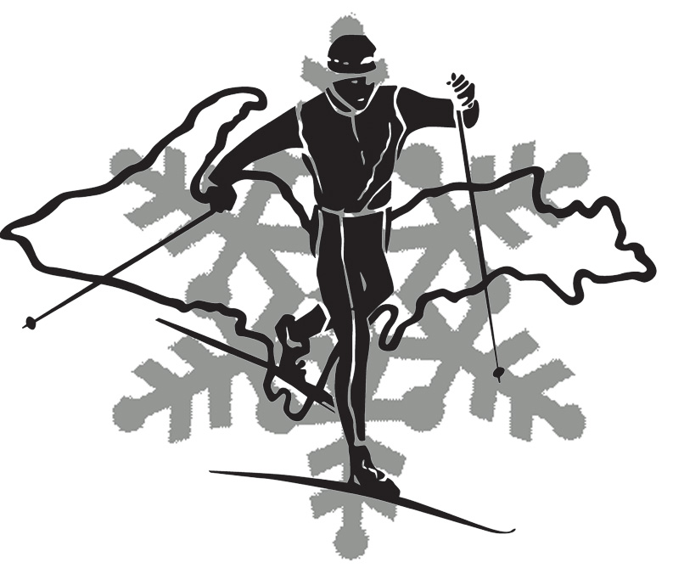
Thank you to our sponsors and volunteers

